**Games Event Management**

Accreditation: The Approve and Reject buttons will be enabled only if the passport status is not set to ‘I do not have a valid passport’

Photo: The Approve and Reject buttons will be enabled only if the photo is uploaded.

The corresponding status will be then updated in the Main section Accreditation.

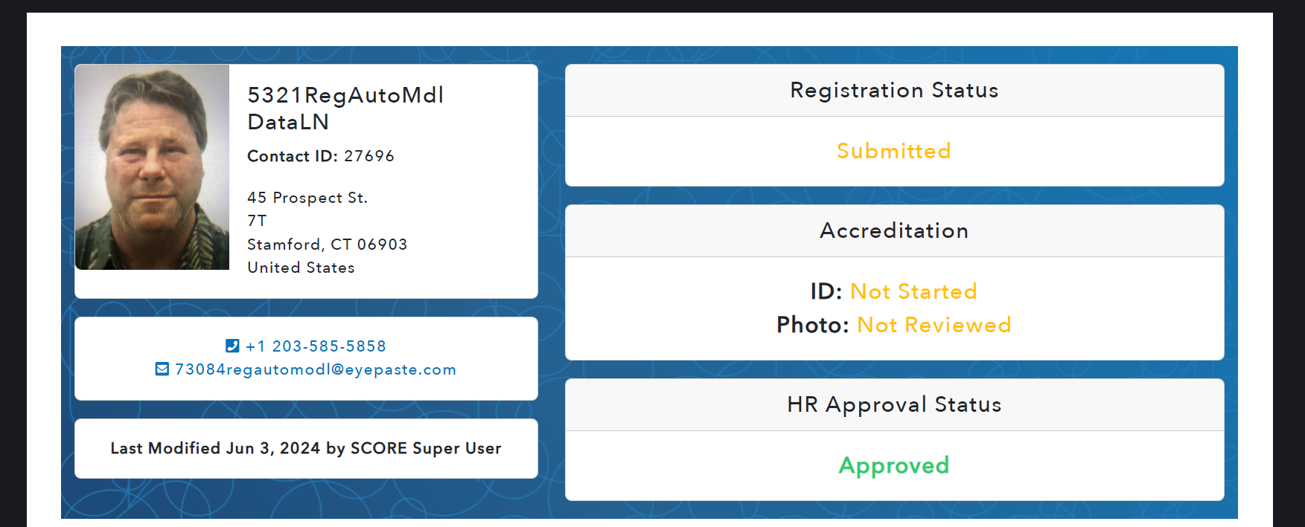

**Contact Details Tab - Read Only**

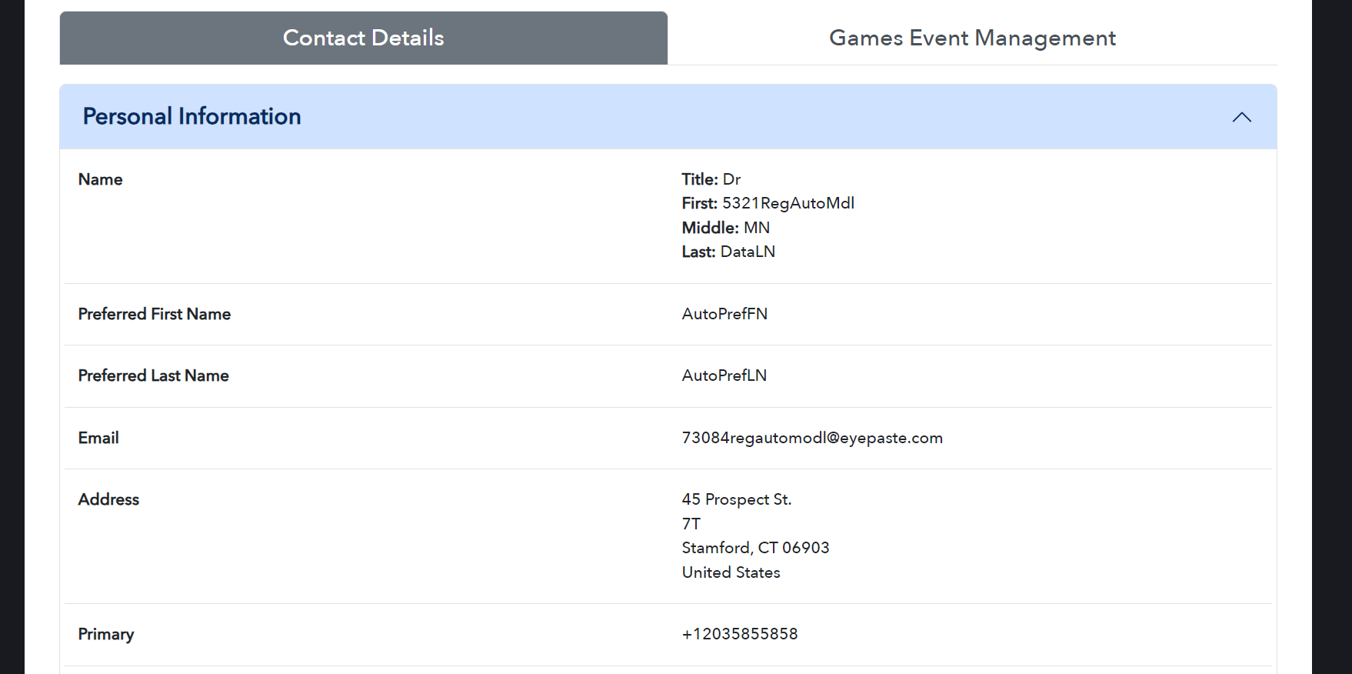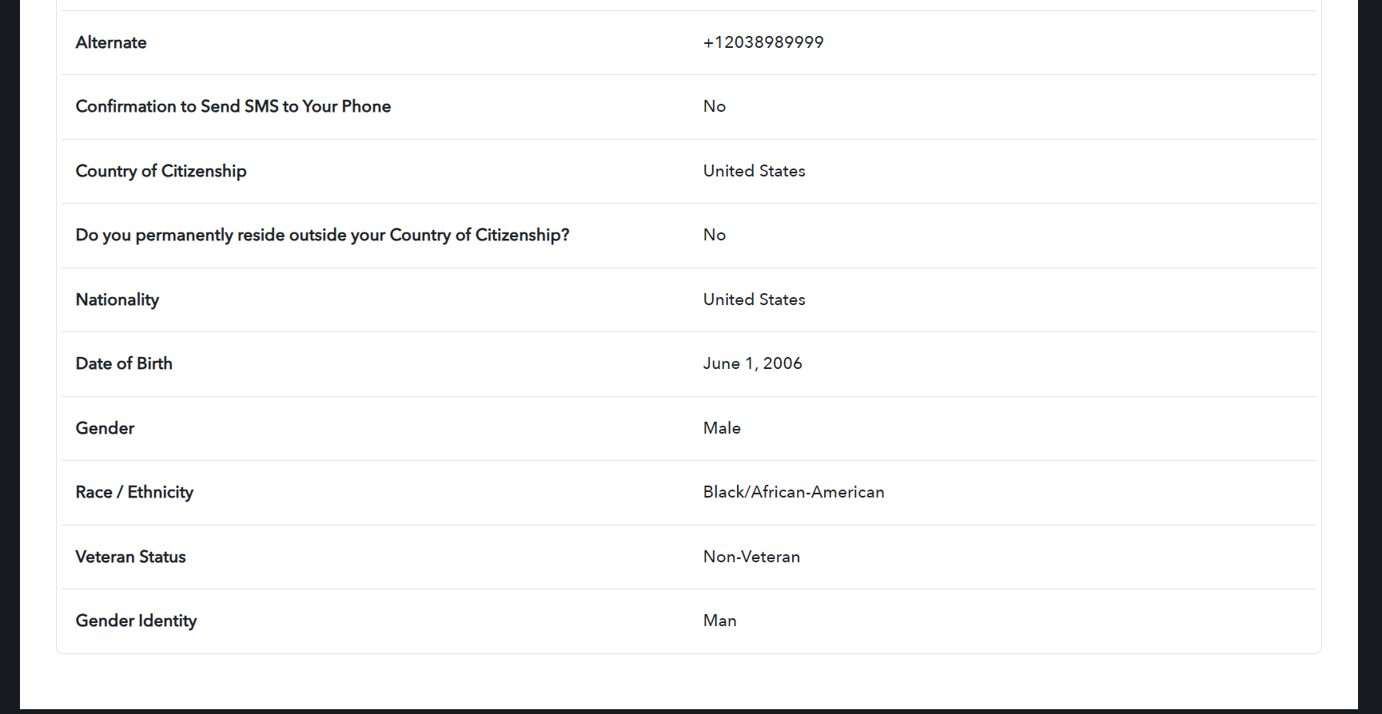

**Games Event Management**

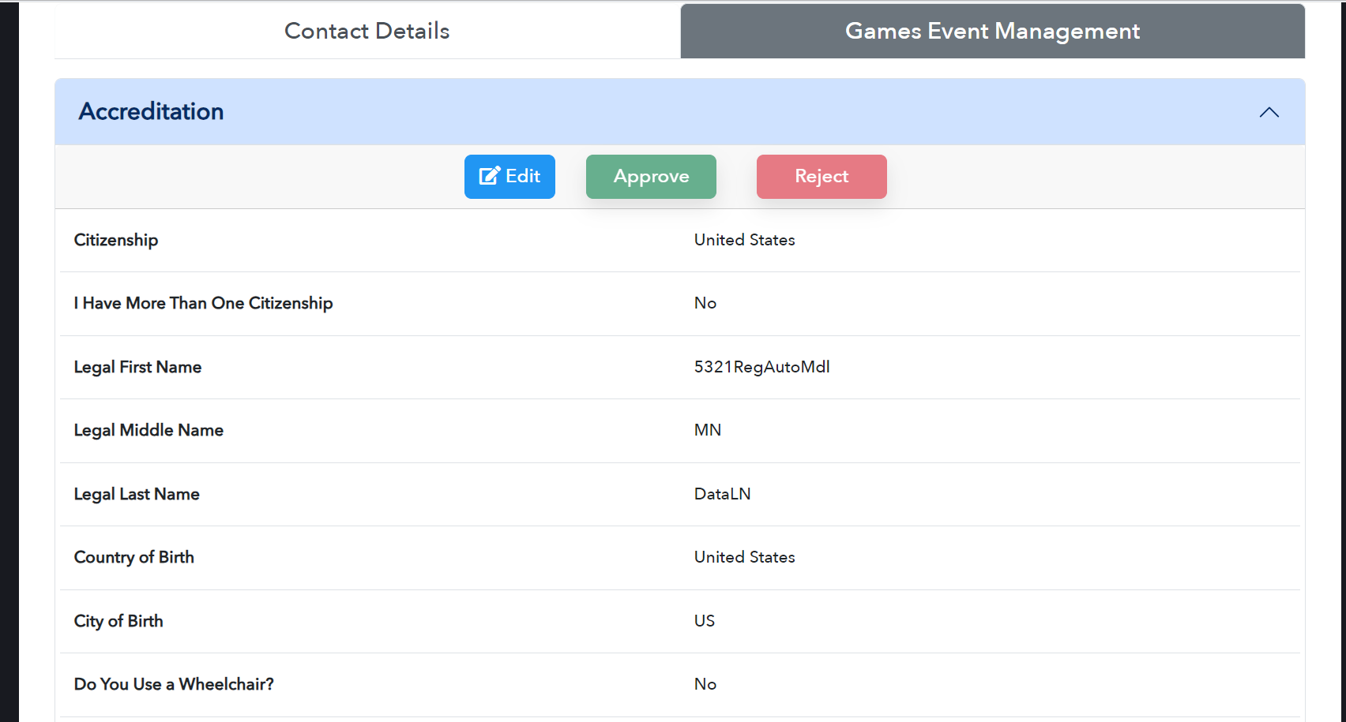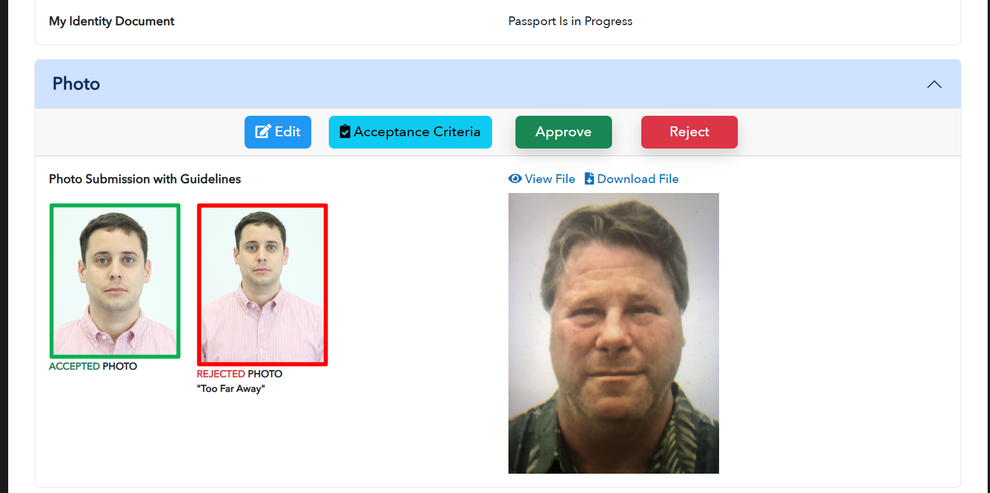

**View File**

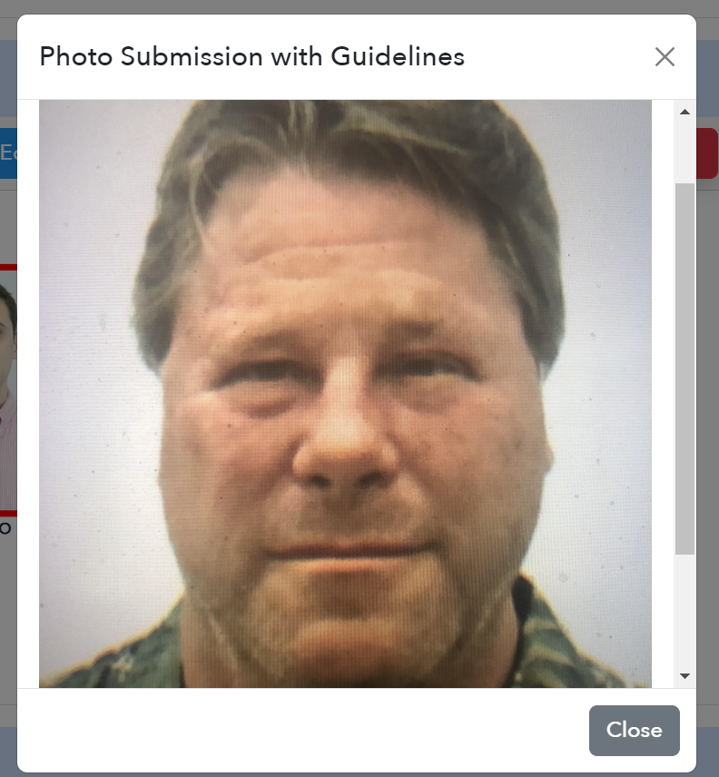

**Download File**

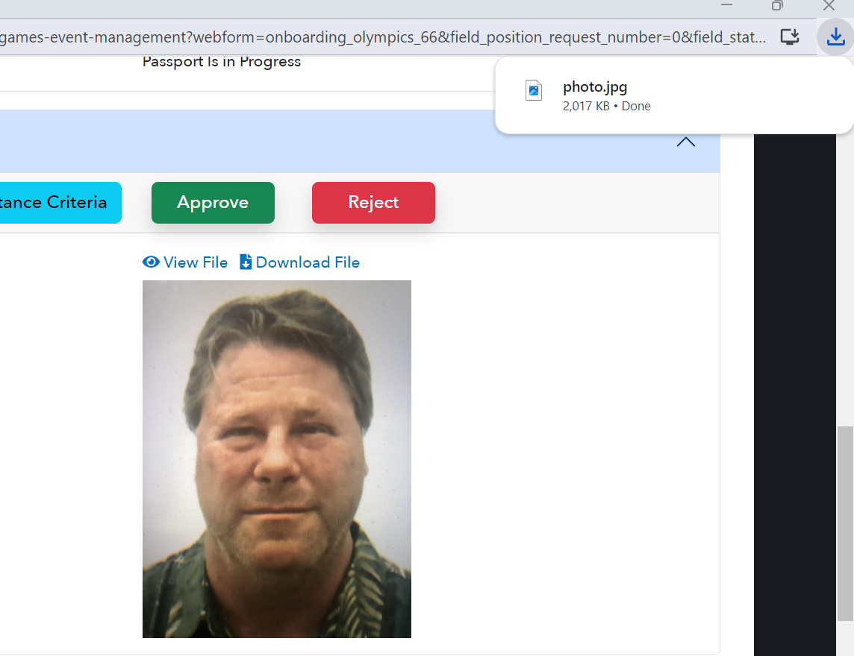

**Acceptance Criteria**

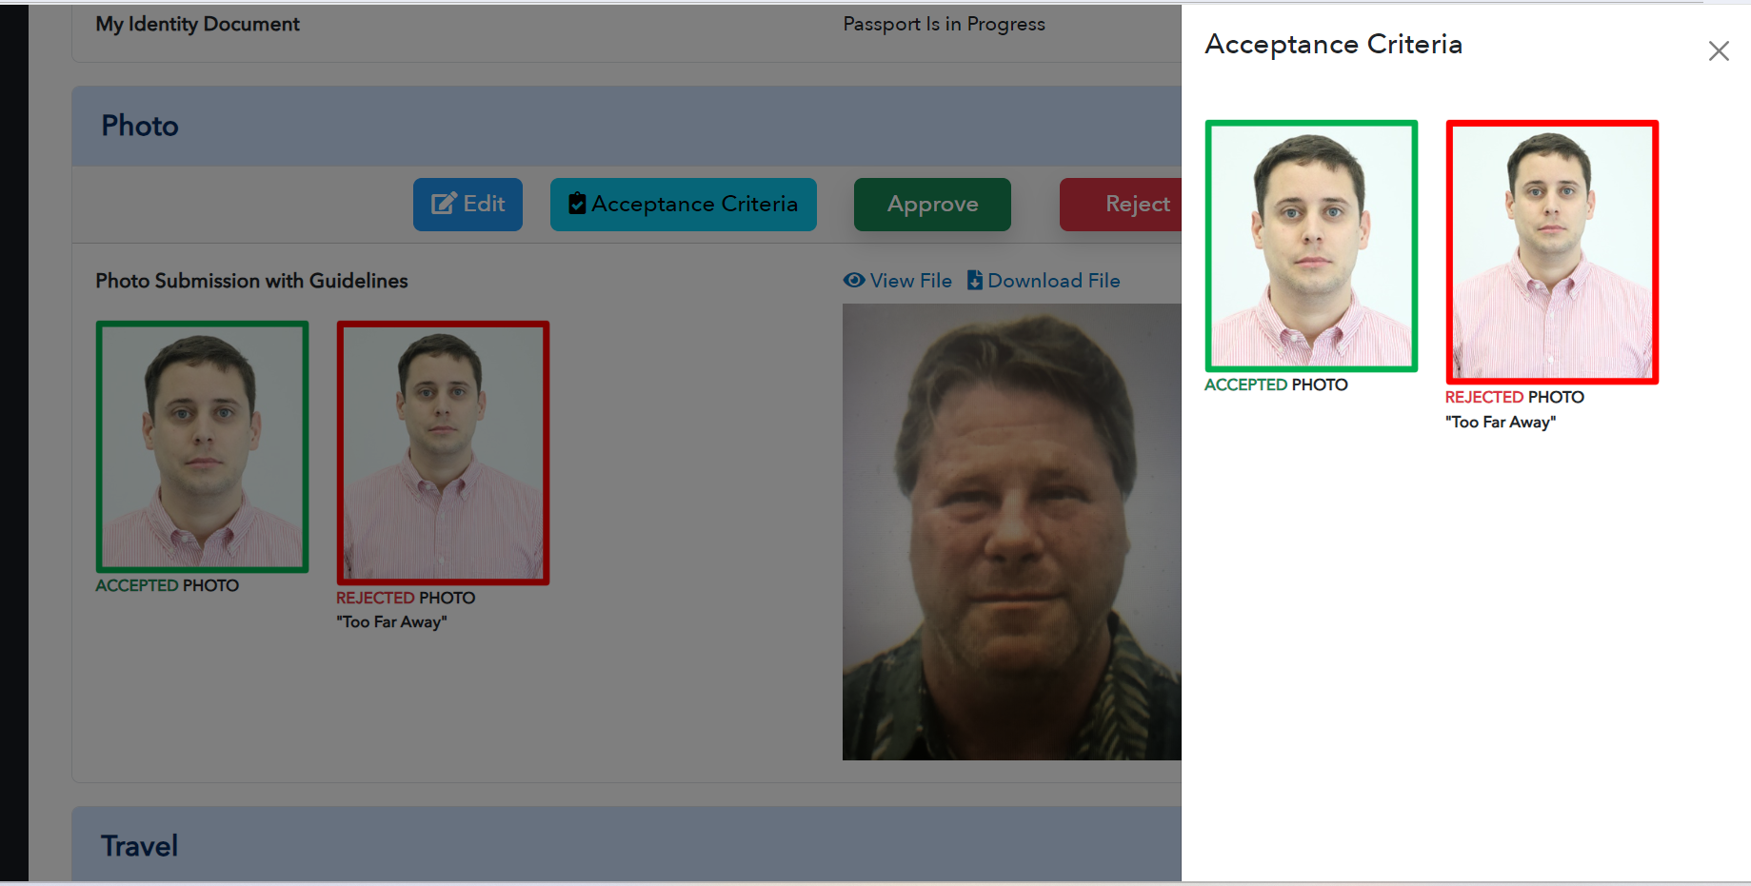

**Approve – Reject –**

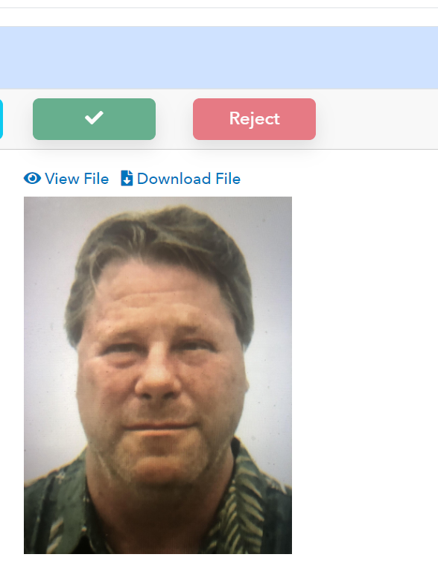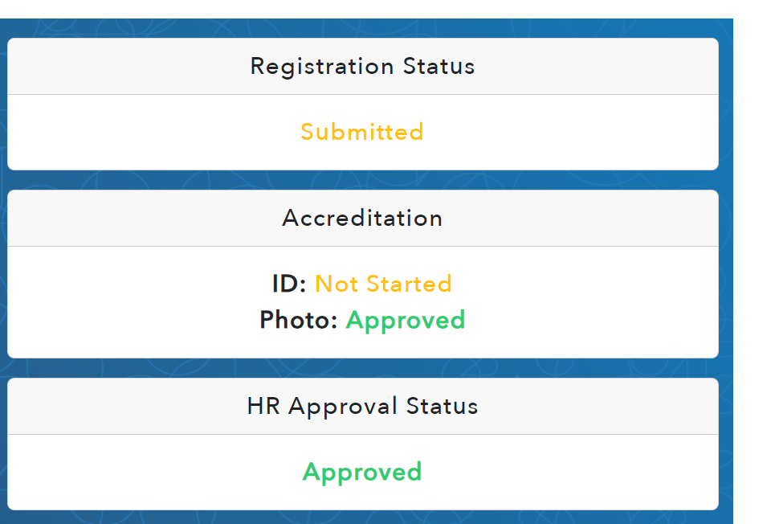

**Travel**

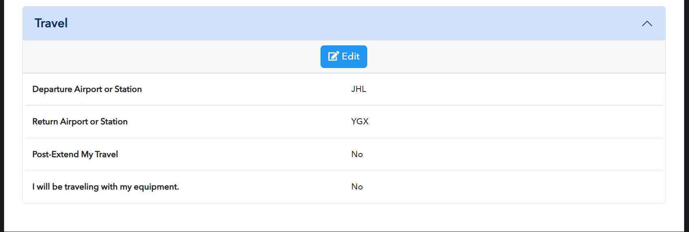

**Edit:**

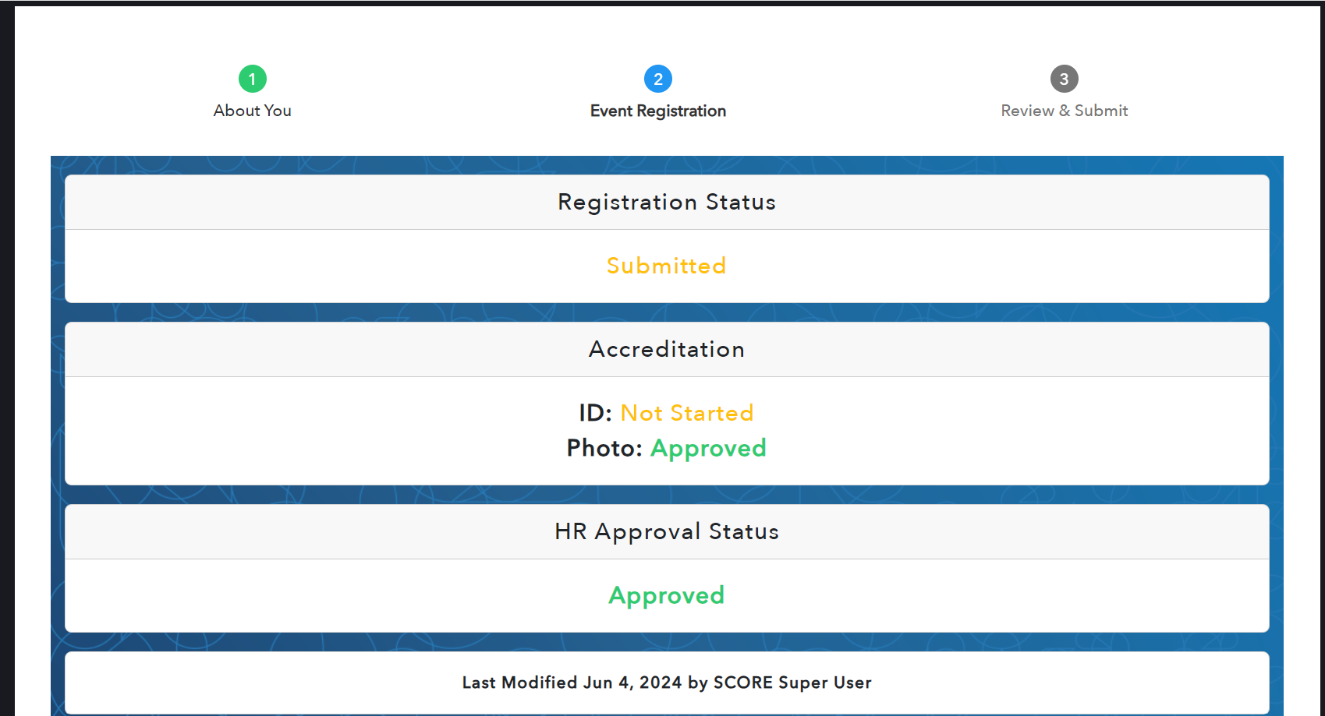

**Contact Details**

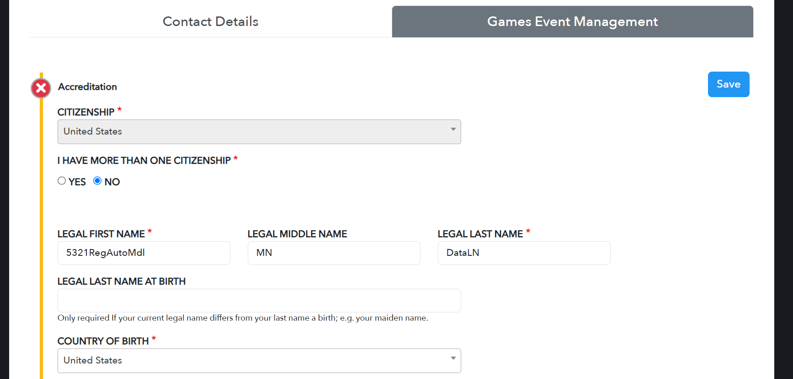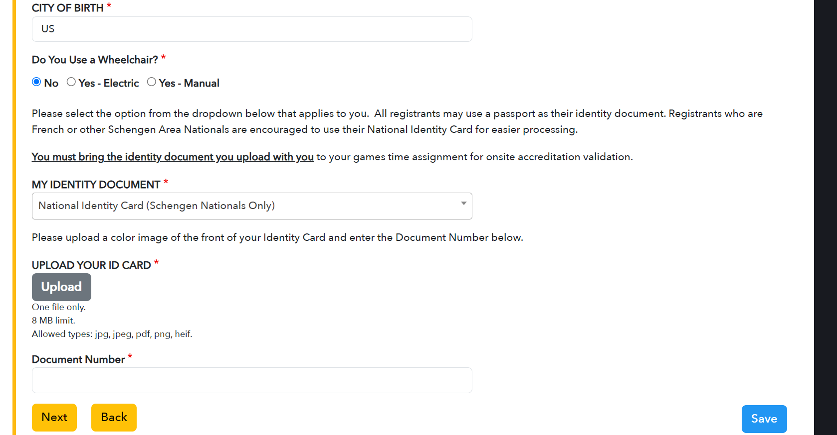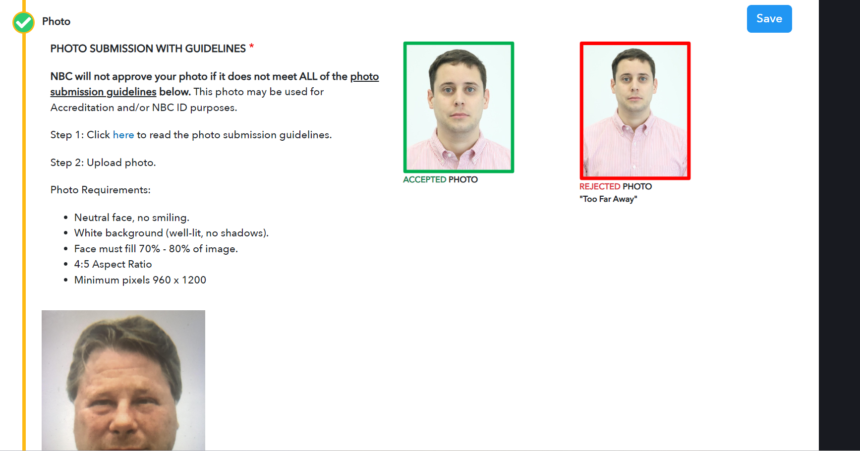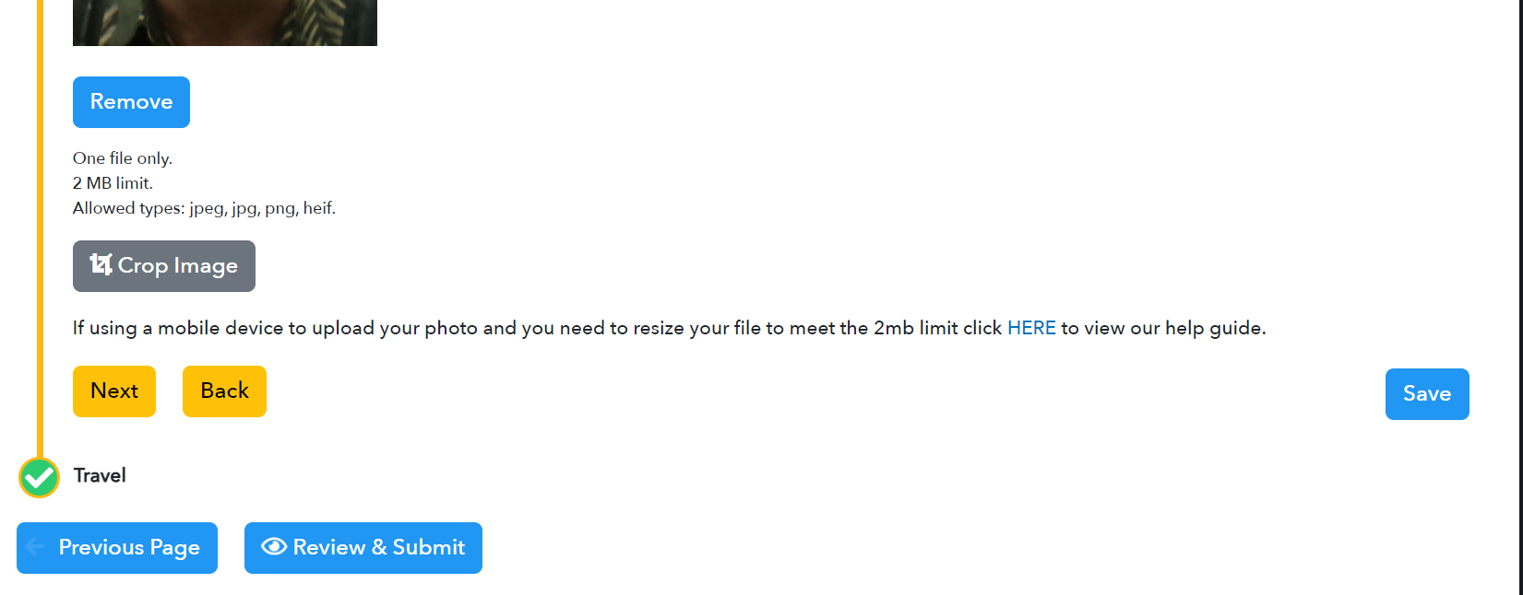

**HERE:** https://s3-us-west-2.amazonaws.com/gateway-nbcsportsgroup-nonprod-public/sites/26b287b7cd5127e3f091b4658e3af9de/files/public/2023/09/Paris2024_PhotoResizingGuide_v2.pdf

**Crop the Image**

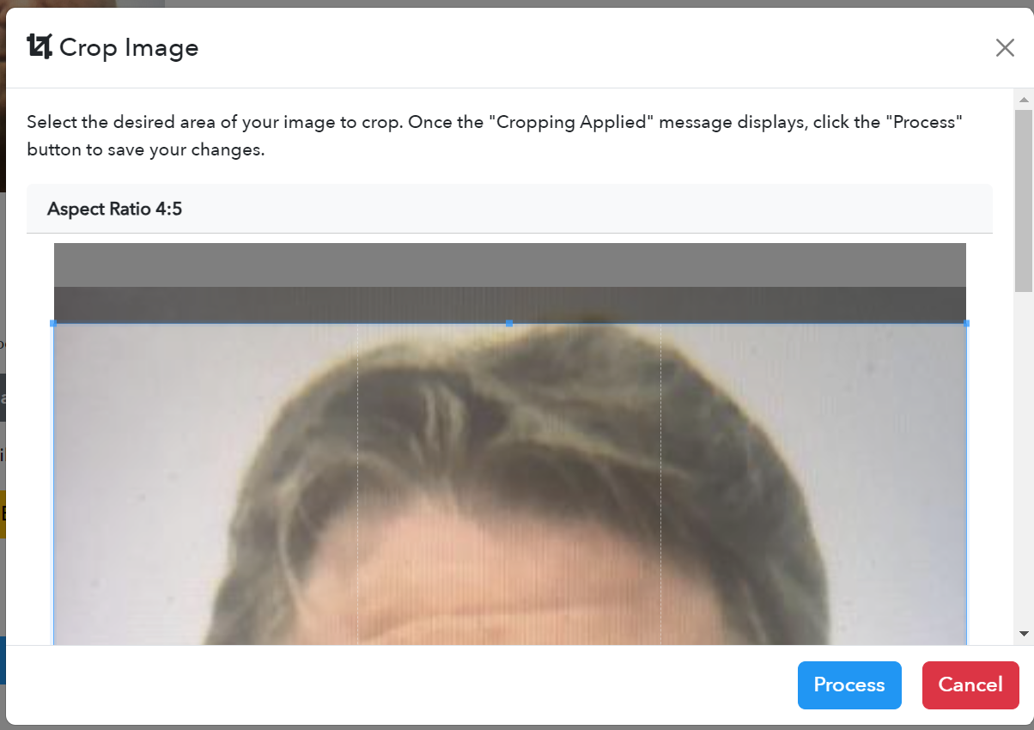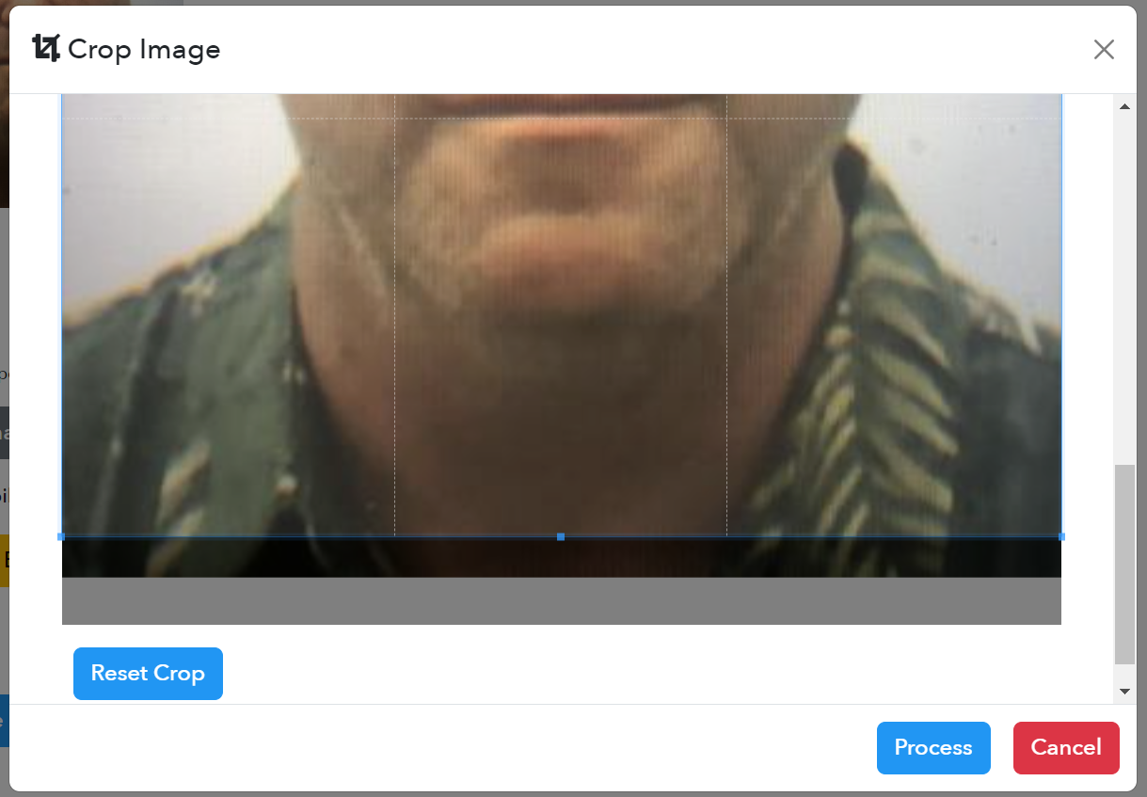

**Cancel**

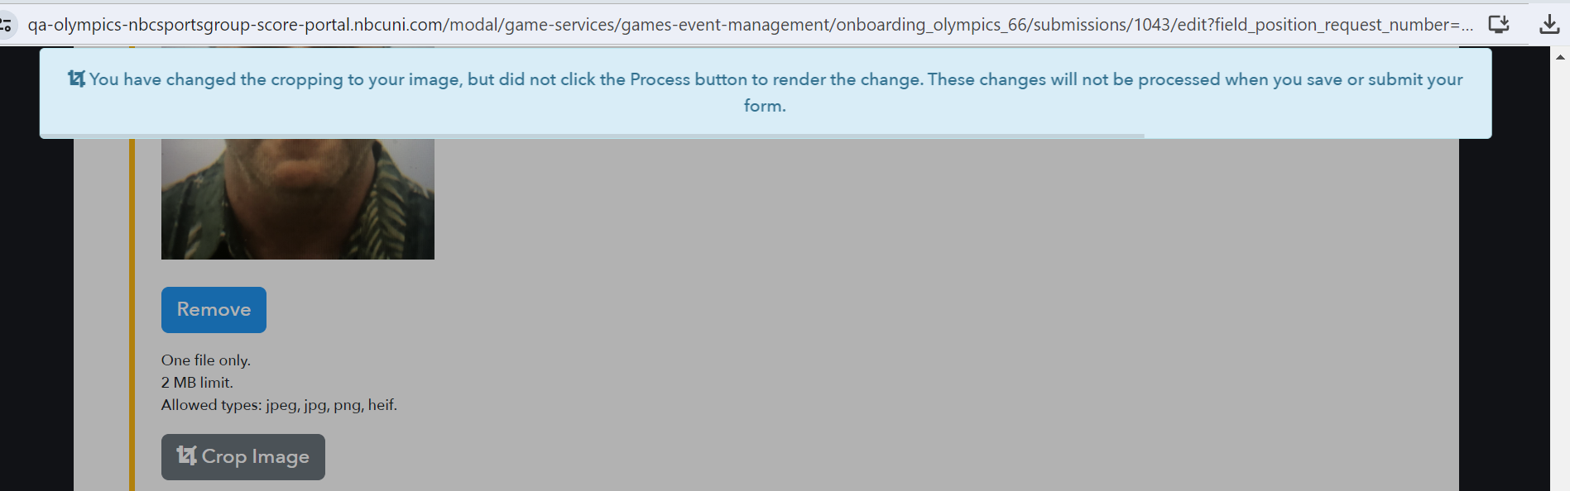

**Process**

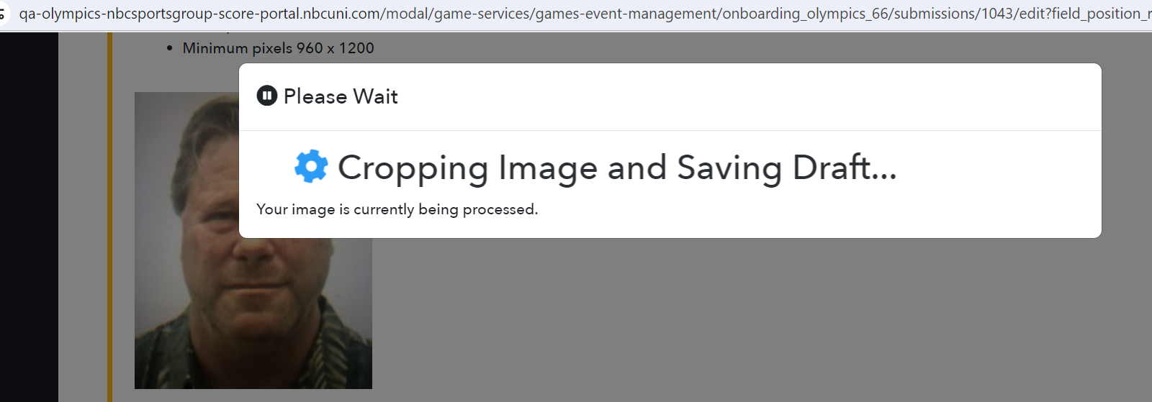

**Expand and Collapsible Photo**

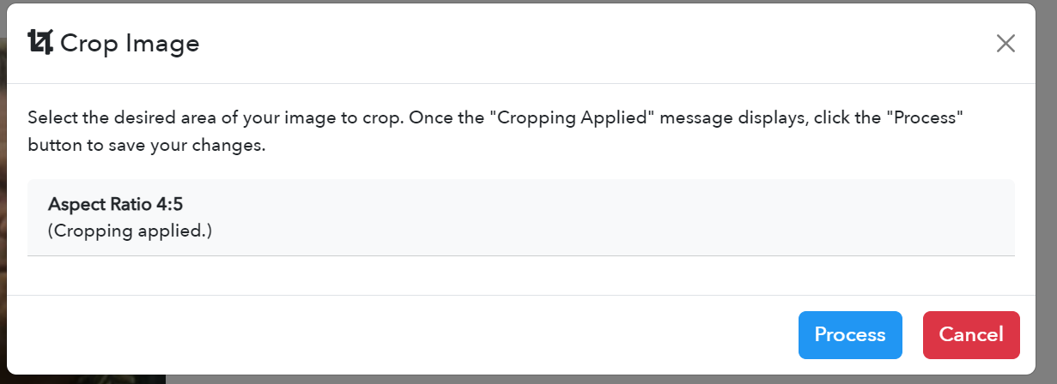

**Travel**

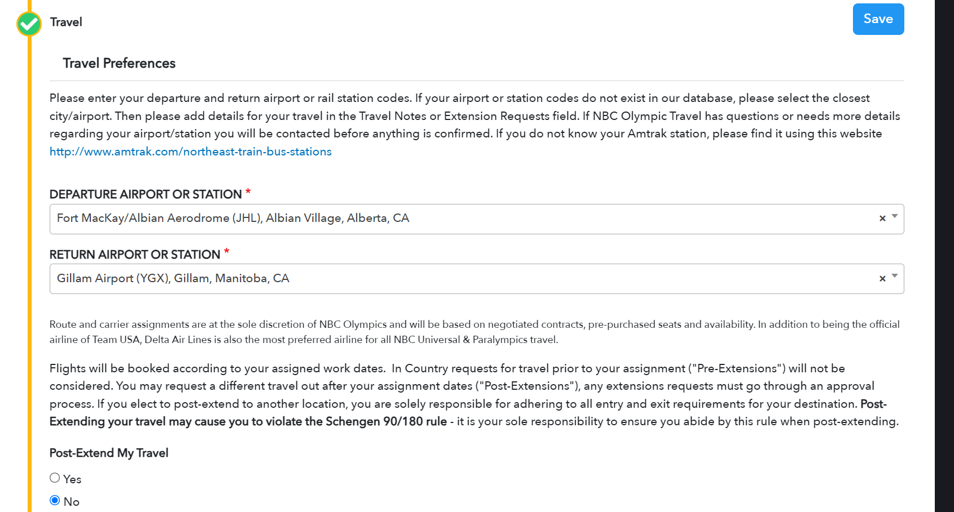 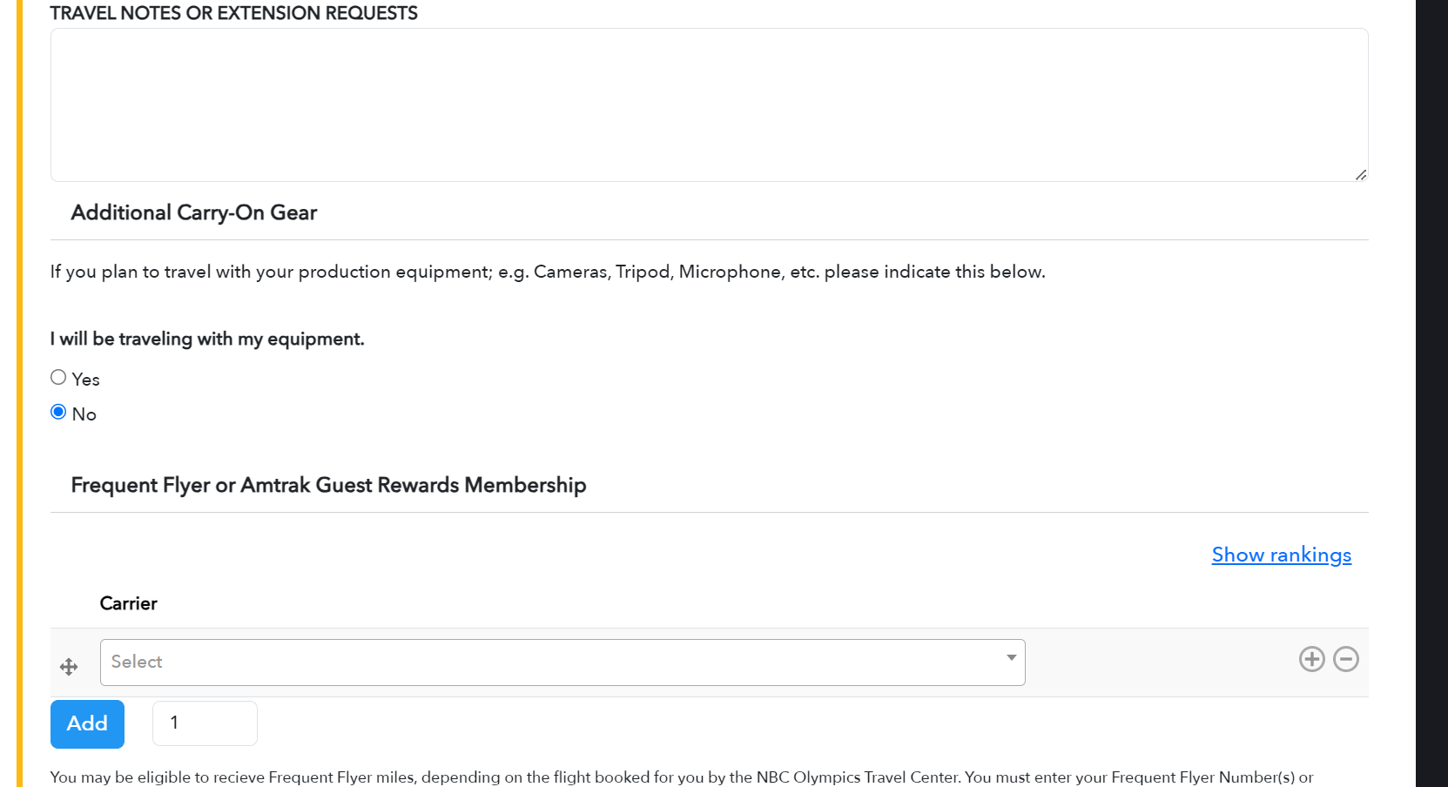 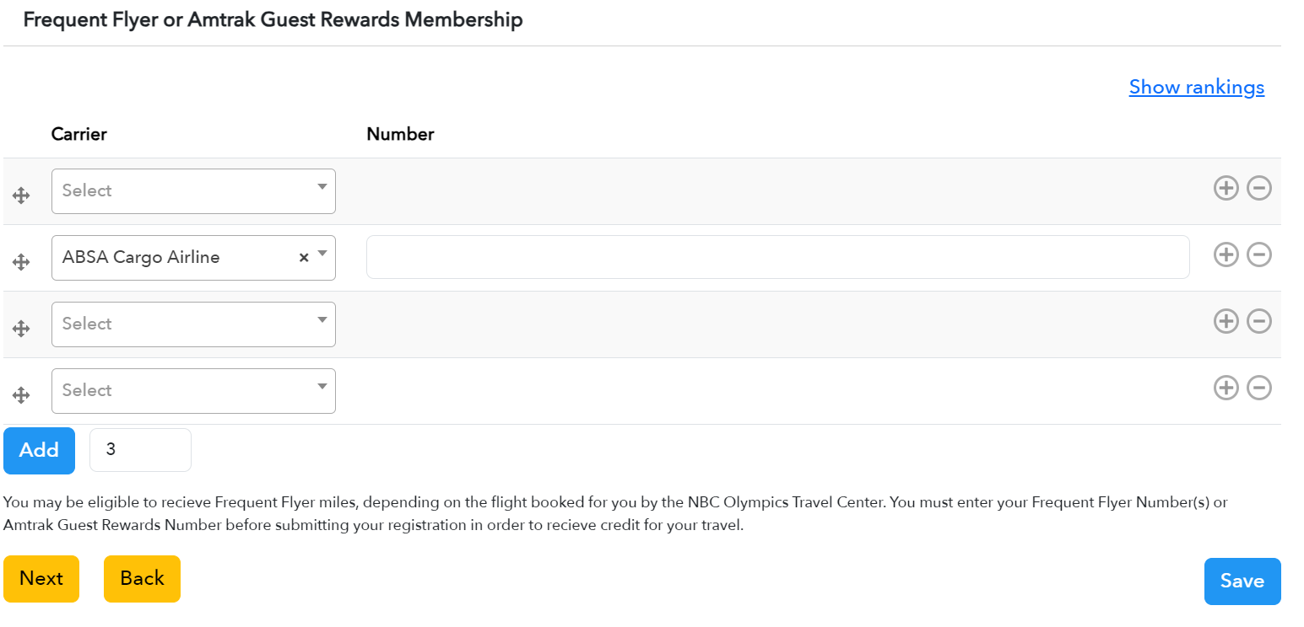

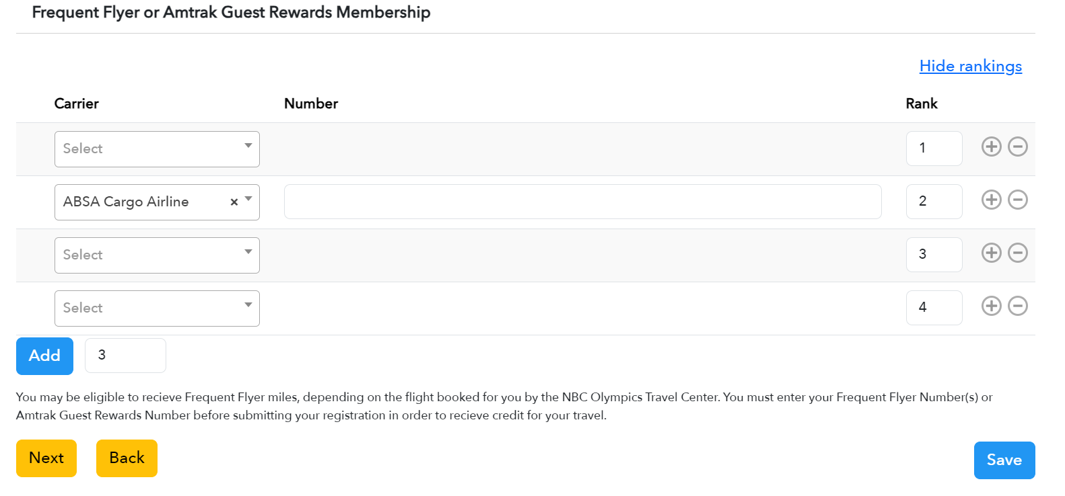

**Next – Automatically scroll to the next section**

**Back – Automatically scroll to the previous section**

**First Page**

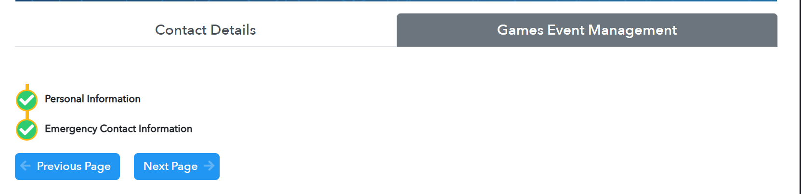

**Previous Page**



**Next page**

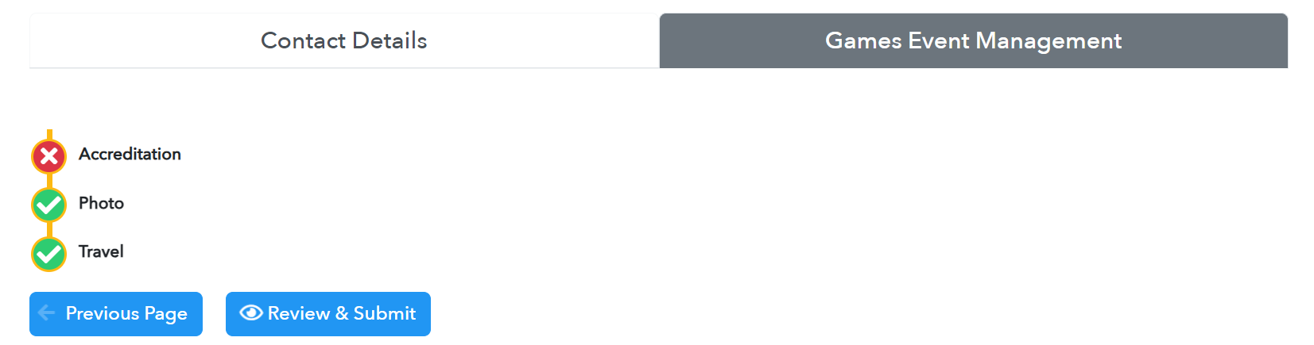



**Review and Submit**

1. **Find all the missing values and show errors**
2. 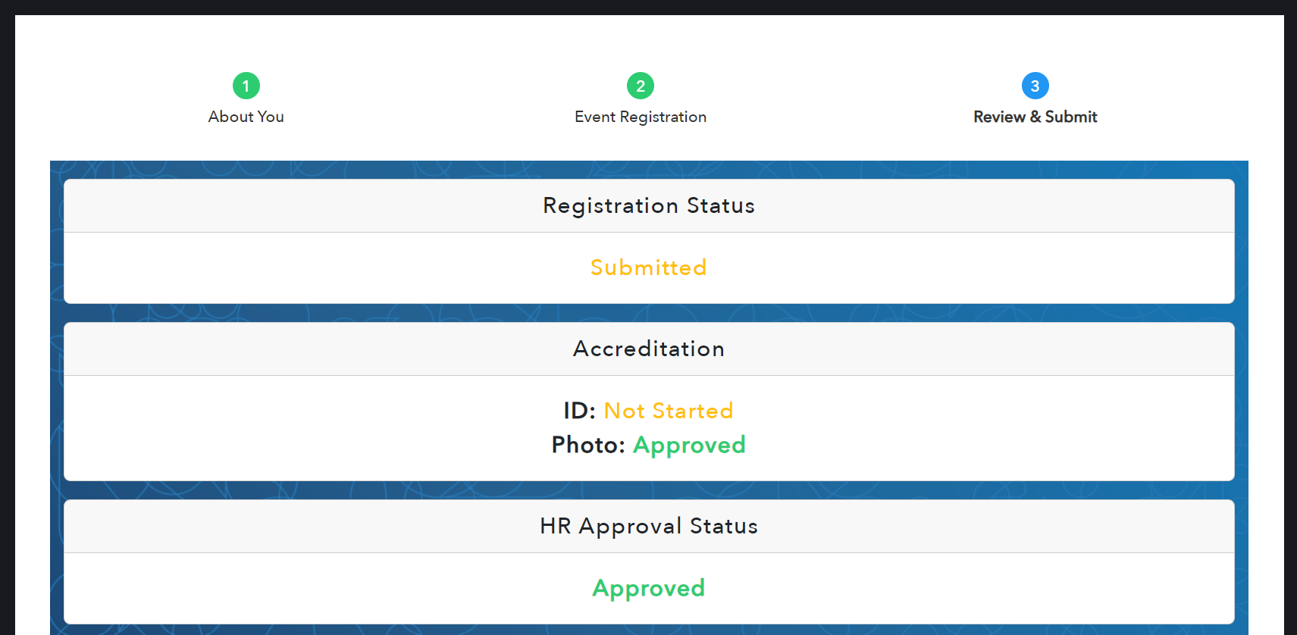 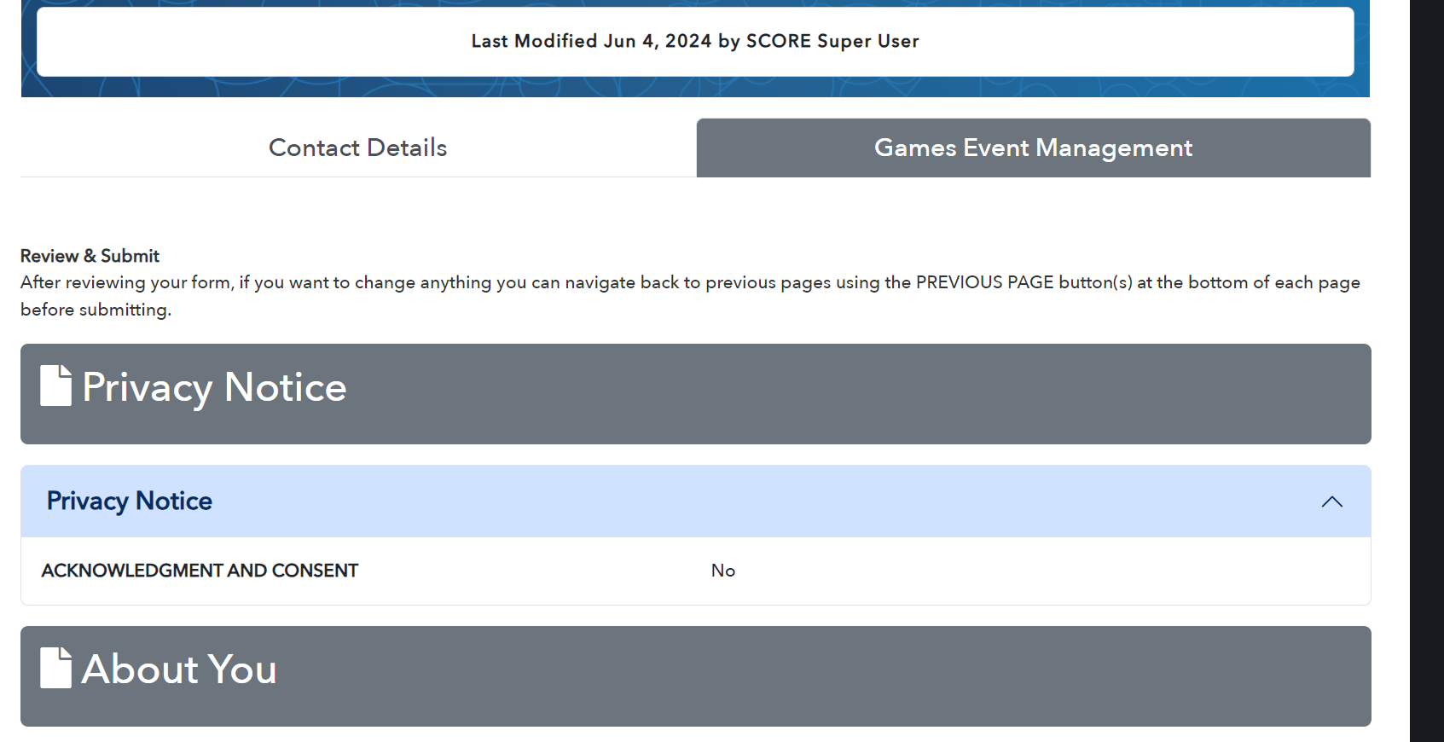 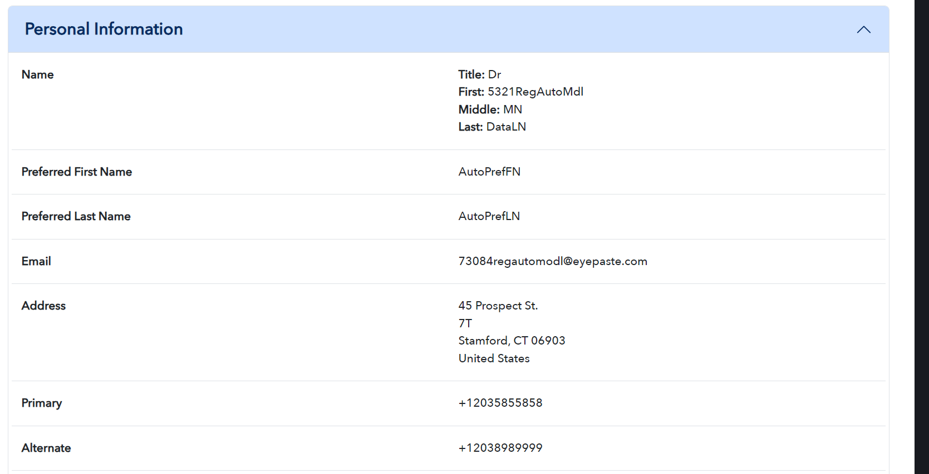 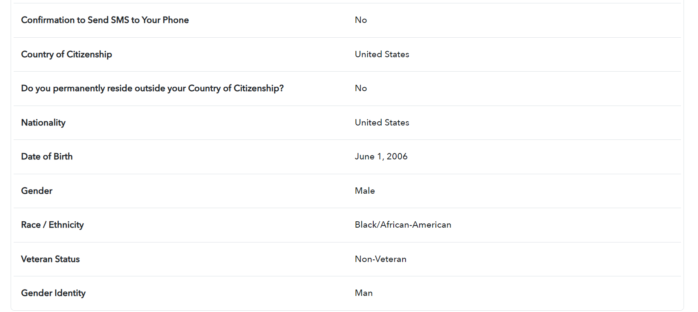 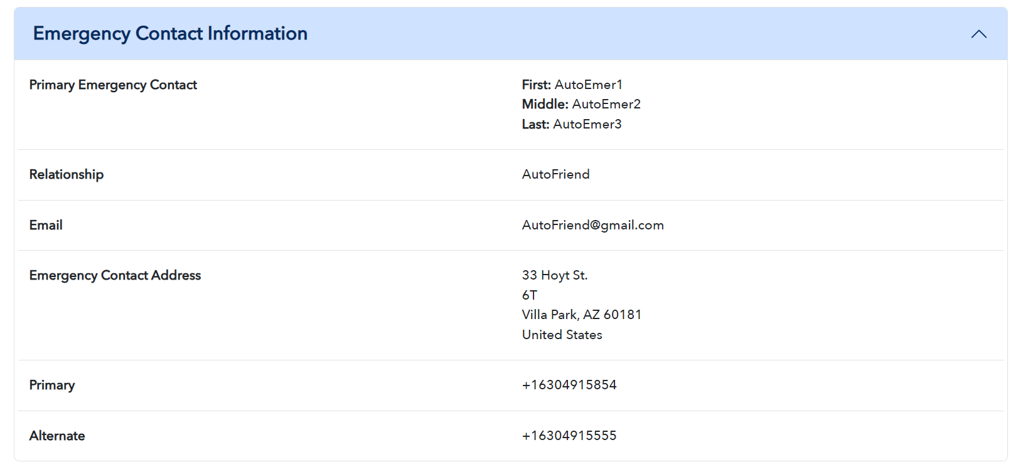 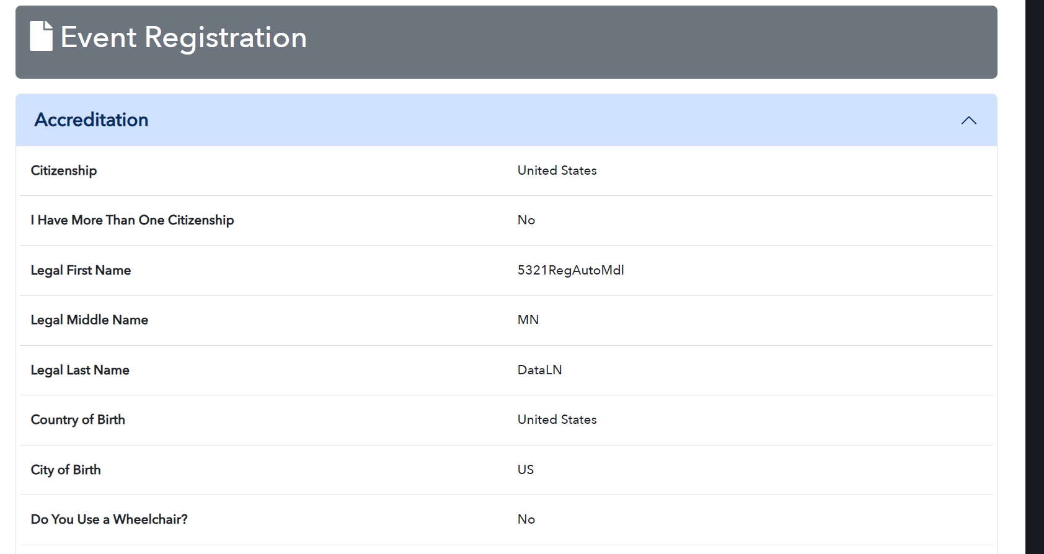 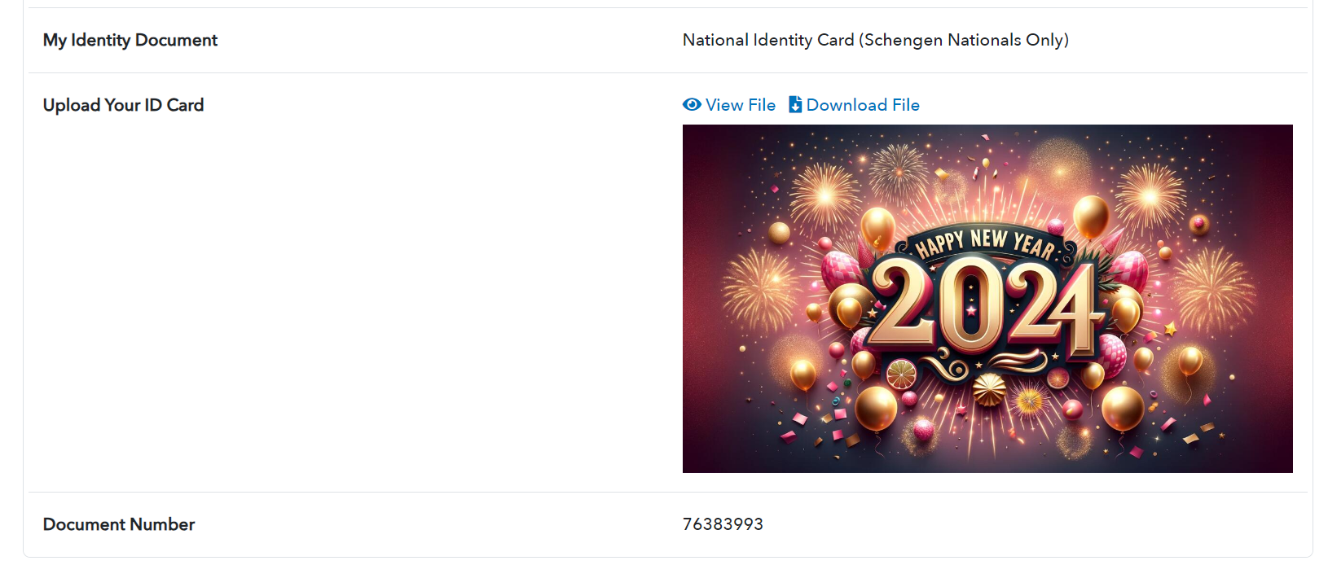 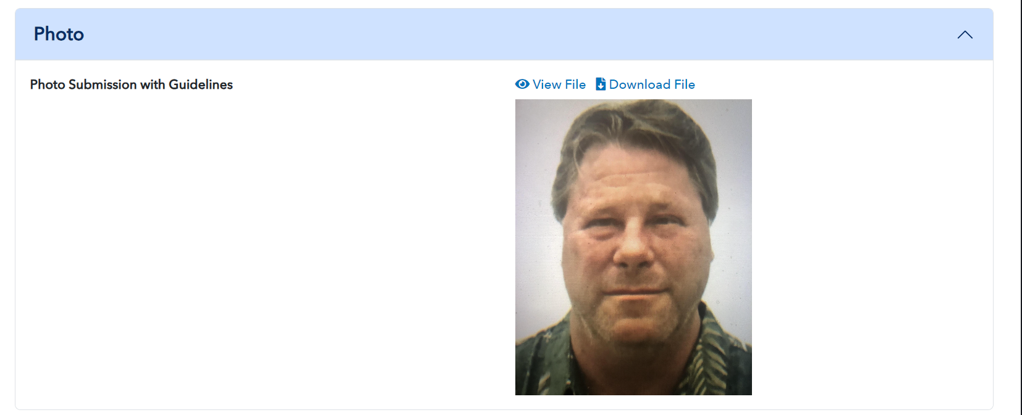 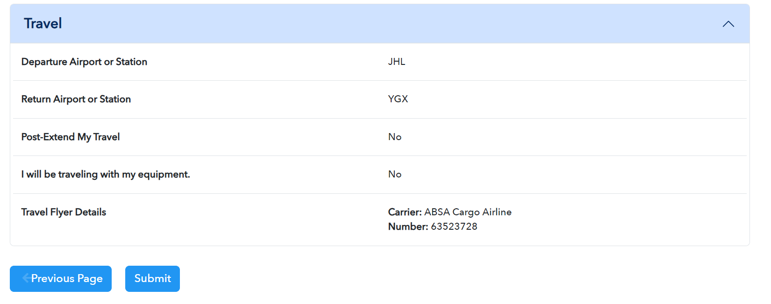

**Crop the image**

**Next and Back Buttons - Navigate above and below in sections**

**Next Page and Previous Page**

**Spinner - NBC**